

BAŞKENT ÜNİVERSİTESİ
ELEKTRİK-ELEKTRONİK MÜHENDİSLİĞİ BÖLÜMÜ

EEM 312~ SAYISAL ELEKTRONİK

LABORATUVAR UYGULAMASI

RAPOR

Deney Adı : Halka osilatörü ve tersleyicinin rejeneratif özelliği
Deney Numarası : Y6
Deney Tarihi : 03.05.2006

Öğrencinin Adı : Oğuz BOZKURT
Öğrencinin Numarası : 20393948

2)
Soru2
.MODEL MOSN NMOS LEVEL=2 LD=0.15U TOX=200.0E-10
+ NSUB=5.36726E+15 VTO=0.743469 KP=8.00059E-05 GAMMA=0.543
+ PHI=0.6 U0=655.881 UEXP=0.157282 UCRIT=31443.8
+ DELTA=2.39824 VMAX=55260.9 XJ=0.25U LAMBDA=0.0367072
+ NFS=1E+12 NEFF=1.001 NSS=1E+11 TPG=1.0 RSH=70.00
+ CGDO=4.3E-10 CGSO=4.3E-10 CJ=0.0003 MJ=0.6585
+ CJSW=8.0E-10 MJSW=0.2402 PB=0.58

.MODEL MOSP PMOS LEVEL=2 LD=0.15U TOX=200.0E-10
+ NSUB=4.3318E+15 VTO=-0.738861 KP=2.70E-05 GAMMA=0.58
+ PHI=0.6 U0=261.977 UEXP=0.323932 UCRIT=65719.8
+ DELTA=1.79192 VMAX=25694 XJ=0.25U LAMBDA=0.0612279
+ NFS=1E+12 NEFF=1.001 NSS=1E+11 TPG=-1.0 RSH=120.6
+ CGDO=4.3E-10 CGSO=4.3E-10 CJ=0.0005 MJ=0.5052
+ CJSW=1.349E-10 MJSW=0.2417 PB=0.64

.subckt inverter 1 2
M1 2 1 0 0 MOSN W=1.8u L=1.2u NRS=0.333 NRD=0.333
+ AD=6.5p PD=9.0u AS=6.5p PS=9.0u
M2 2 1 3 3 MOSP W=5.4u L=1.2u NRS=0.333 NRD=0.333
+ AD=6.5p PD=9.0u AS=6.5p PS=9.0u
CL 2 0 0.1P
VDD 3 0 3.2V
.ends

vin 1 0 Pulse(0 3.2 0 1n 1n 100n 200n)
xinva 1 2 inverter

.control
TRAN 1NS 200nS
plot v(2) v(1)
.endc
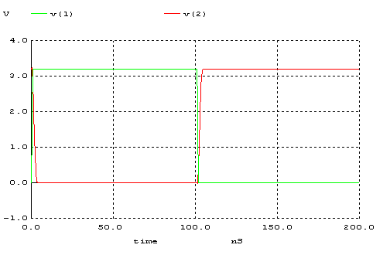
Ölçümler:
tp_{HL}=1.023ns
tp_{LH} =1.133ns
td= .1078ns

Grafikte de görüldüğü gibi devre olması gerektiği şekilde çalışmıştır. Giriş sinyali çıkışta terslenmiştir.

3.1)
soru3_1

.MODEL MOSN NMOS LEVEL=2 LD=0.15U TOX=200.0E-10
+ NSUB=5.36726E+15 VTO=0.743469 KP=8.00059E-05 GAMMA=0.543
+ PHI=0.6 U0=655.881 UEXP=0.157282 UCRIT=31443.8
+ DELTA=2.39824 VMAX=55260.9 XJ=0.25U LAMBDA=0.0367072
+ NFS=1E+12 NEFF=1.001 NSS=1E+11 TPG=1.0 RSH=70.00
+ CGDO=4.3E-10 CGSO=4.3E-10 CJ=0.0003 MJ=0.6585
+ CJSW=8.0E-10 MJSW=0.2402 PB=0.58

.MODEL MOSP PMOS LEVEL=2 LD=0.15U TOX=200.0E-10
+ NSUB=4.3318E+15 VTO=-0.738861 KP=2.70E-05 GAMMA=0.58
+ PHI=0.6 U0=261.977 UEXP=0.323932 UCRIT=65719.8
+ DELTA=1.79192 VMAX=25694 XJ=0.25U LAMBDA=0.0612279
+ NFS=1E+12 NEFF=1.001 NSS=1E+11 TPG=-1.0 RSH=120.6
+ CGDO=4.3E-10 CGSO=4.3E-10 CJ=0.0005 MJ=0.5052
+ CJSW=1.349E-10 MJSW=0.2417 PB=0.64

.subckt inverter 1 2
M1 2 1 0 0 MOSN W=1.8u L=1.2u NRS=0.111 NRD=0.111
+ AD=6.5p PD=9.0u AS=6.5p PS=9.0u
M2 2 1 3 3 MOSP W=5.4u L=1.2u NRS=0.333 NRD=0.333
+ AD=6.5p PD=9.0u AS=6.5p PS=9.0u
VDD 3 0 3.2V
.ends

VIN 1 0 0
CL1 6 0 0.1P

xinva 1 2 inverter
xinvb 2 3 inverter
xinvc 3 4 inverter
xinvd 4 5 inverter
xinve 5 6 inverter

.control
DC VIN 0 3.2 0.01
plot V(2) VS v(1)
plot V(3) VS v(1)
plot V(4) VS v(1)
plot V(5) VS v(1)
plot V(6) VS v(1)
.endc

Vin - A
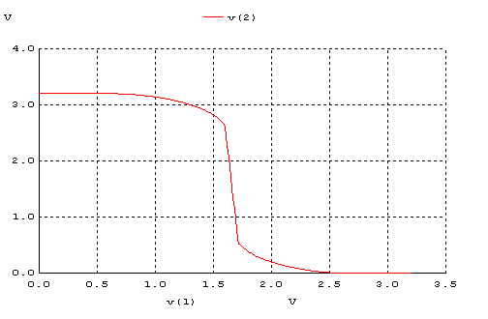
Vin - B
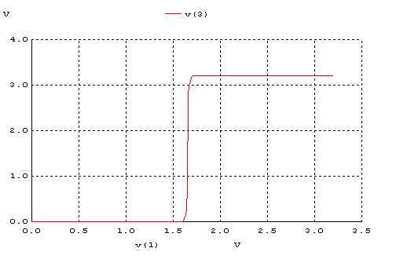
Vin - C
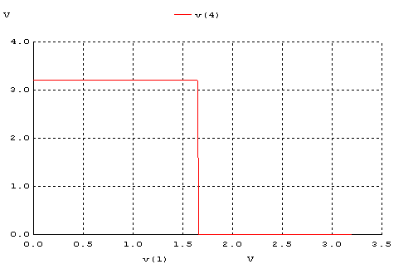

Vin - D
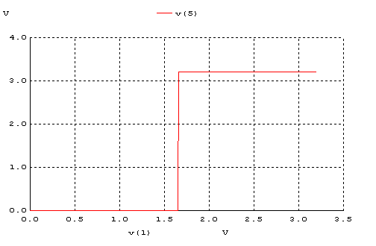
Vin - Vout
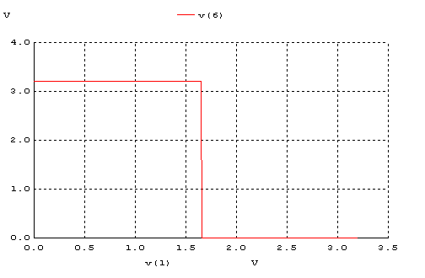

Grafikleri karşılaştırdığımızda ilk inverterın çıışındaki bozuk sinyalin, ring osilatöründen geçtikten sonra ideale yaklaştığını görürüz. Bunun nedeni devrenin rejeneratif olmasıdır.

3.2)
soru3_2

.MODEL MOSN NMOS LEVEL=2 LD=0.15U TOX=200.0E-10
+ NSUB=5.36726E+15 VTO=0.743469 KP=8.00059E-05 GAMMA=0.543
+ PHI=0.6 U0=655.881 UEXP=0.157282 UCRIT=31443.8
+ DELTA=2.39824 VMAX=55260.9 XJ=0.25U LAMBDA=0.0367072
+ NFS=1E+12 NEFF=1.001 NSS=1E+11 TPG=1.0 RSH=70.00
+ CGDO=4.3E-10 CGSO=4.3E-10 CJ=0.0003 MJ=0.6585
+ CJSW=8.0E-10 MJSW=0.2402 PB=0.58

.MODEL MOSP PMOS LEVEL=2 LD=0.15U TOX=200.0E-10
+ NSUB=4.3318E+15 VTO=-0.738861 KP=2.70E-05 GAMMA=0.58
+ PHI=0.6 U0=261.977 UEXP=0.323932 UCRIT=65719.8
+ DELTA=1.79192 VMAX=25694 XJ=0.25U LAMBDA=0.0612279
+ NFS=1E+12 NEFF=1.001 NSS=1E+11 TPG=-1.0 RSH=120.6
+ CGDO=4.3E-10 CGSO=4.3E-10 CJ=0.0005 MJ=0.5052
+ CJSW=1.349E-10 MJSW=0.2417 PB=0.64

.subckt inverter 1 2
M1 2 1 0 0 MOSN W=1.8u L=1.2u NRS=0.333 NRD=0.333
+ AD=6.5p PD=9.0u AS=6.5p PS=9.0u
M2 2 1 3 3 MOSP W=5.4u L=1.2u NRS=0.333 NRD=0.333
+ AD=6.5p PD=9.0u AS=6.5p PS=9.0u
VDD 3 0 3.2V
.ends

VIN 1 0 Pulse(0 3.2 0 1n 1n 100n 200n)
CL1 6 0 0.1P

xinva 1 2 inverter
xinvb 2 3 inverter
xinvc 3 4 inverter
xinvd 4 5 inverter
xinve 5 6 inverter

.control
TRAN 0.1NS 200NS
plot V(1) V(2) V(3) V(4) V(5) V(6)
.endc

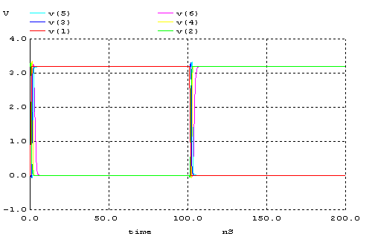

Vin-V(A) tp_{LH} = 0.414ns
V(A)-V(B) tp_{HL} = 0.401ns
V(B)-V(C) tp_{LH} = 0.352ns
V(C)-V(D) tp_{HL} = 0,401ns
Vin-Vout tp_{LH} = 0.973ns (Kapasitör (C_{L}) dolduğu için daha uzun sürede dolmuştur.)

3.3)
soru3_3

.MODEL MOSN NMOS LEVEL=2 LD=0.15U TOX=200.0E-10
+ NSUB=5.36726E+15 VTO=0.743469 KP=8.00059E-05 GAMMA=0.543
+ PHI=0.6 U0=655.881 UEXP=0.157282 UCRIT=31443.8
+ DELTA=2.39824 VMAX=55260.9 XJ=0.25U LAMBDA=0.0367072
+ NFS=1E+12 NEFF=1.001 NSS=1E+11 TPG=1.0 RSH=70.00
+ CGDO=4.3E-10 CGSO=4.3E-10 CJ=0.0003 MJ=0.6585
+ CJSW=8.0E-10 MJSW=0.2402 PB=0.58

.MODEL MOSP PMOS LEVEL=2 LD=0.15U TOX=200.0E-10
+ NSUB=4.3318E+15 VTO=-0.738861 KP=2.70E-05 GAMMA=0.58
+ PHI=0.6 U0=261.977 UEXP=0.323932 UCRIT=65719.8
+ DELTA=1.79192 VMAX=25694 XJ=0.25U LAMBDA=0.0612279
+ NFS=1E+12 NEFF=1.001 NSS=1E+11 TPG=-1.0 RSH=120.6
+ CGDO=4.3E-10 CGSO=4.3E-10 CJ=0.0005 MJ=0.5052
+ CJSW=1.349E-10 MJSW=0.2417 PB=0.64

.subckt inverter 1 2
M1 2 1 0 0 MOSN W=1.8u L=1.2u NRS=0.111 NRD=0.111
+ AD=6.5p PD=9.0u AS=6.5p PS=9.0u
M2 2 1 3 3 MOSP W=5.4u L=1.2u NRS=0.333 NRD=0.333
+ AD=6.5p PD=9.0u AS=6.5p PS=9.0u
VDD 3 0 3.2V
.ends

VIN 1 0 SIN(1.6 1 5E6 0 0)
CL1 6 0 0.1P

xinva 1 2 inverter
xinvb 2 3 inverter
xinvc 3 4 inverter
xinvd 4 5 inverter
xinve 5 6 inverter

.control
TRAN 0.1NS 200NS
plot V(1) V(2) V(3) V(4) V(5)
.endc

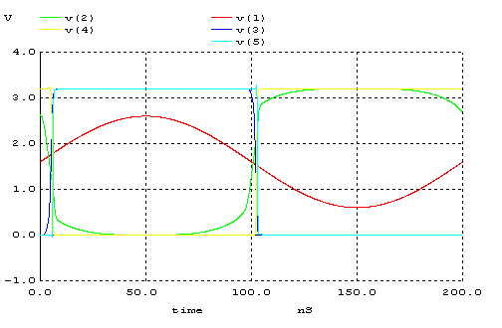

Bu devre, girişe uygulanan sinüsoidal bir dalgayı ring osilatörüyle çıkışta ideale yakın bir kare dalga haline getirmektedir.

4.1)
soru4_1

.MODEL MOSN NMOS LEVEL=2 LD=0.15U TOX=200.0E-10
+ NSUB=5.36726E+15 VTO=0.743469 KP=8.00059E-05 GAMMA=0.543
+ PHI=0.6 U0=655.881 UEXP=0.157282 UCRIT=31443.8
+ DELTA=2.39824 VMAX=55260.9 XJ=0.25U LAMBDA=0.0367072
+ NFS=1E+12 NEFF=1.001 NSS=1E+11 TPG=1.0 RSH=70.00
+ CGDO=4.3E-10 CGSO=4.3E-10 CJ=0.0003 MJ=0.6585
+ CJSW=8.0E-10 MJSW=0.2402 PB=0.58

.MODEL MOSP PMOS LEVEL=2 LD=0.15U TOX=200.0E-10
+ NSUB=4.3318E+15 VTO=-0.738861 KP=2.70E-05 GAMMA=0.58
+ PHI=0.6 U0=261.977 UEXP=0.323932 UCRIT=65719.8
+ DELTA=1.79192 VMAX=25694 XJ=0.25U LAMBDA=0.0612279
+ NFS=1E+12 NEFF=1.001 NSS=1E+11 TPG=-1.0 RSH=120.6
+ CGDO=4.3E-10 CGSO=4.3E-10 CJ=0.0005 MJ=0.5052
+ CJSW=1.349E-10 MJSW=0.2417 PB=0.64

.subckt inverter 1 2
M1 2 1 0 0 MOSN W=1.8u L=1.2u NRS=0.333 NRD=0.333
+ AD=6.5p PD=9.0u AS=6.5p PS=9.0u
M2 2 1 3 3 MOSP W=5.4u L=1.2u NRS=0.333 NRD=0.333
+ AD=6.5p PD=9.0u AS=6.5p PS=9.0u
VDD 3 0 3.2V
.ends

xinva 1 2 inverter
xinvb 2 3 inverter
xinvc 3 4 inverter
xinvd 4 5 inverter
xinve 5 1 inverter

.control
TRAN 0.01NS 15NS
PLOT V(1) V(2) V(3) V(4) V(5)
.endc

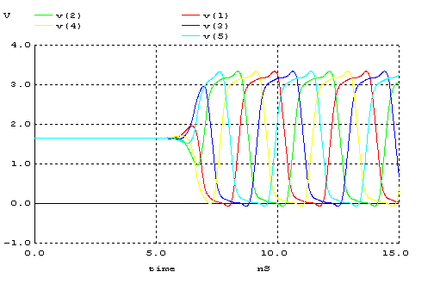

4.2)
soru4_2

.MODEL MOSN NMOS LEVEL=2 LD=0.15U TOX=200.0E-10
+ NSUB=5.36726E+15 VTO=0.743469 KP=8.00059E-05 GAMMA=0.543
+ PHI=0.6 U0=655.881 UEXP=0.157282 UCRIT=31443.8
+ DELTA=2.39824 VMAX=55260.9 XJ=0.25U LAMBDA=0.0367072
+ NFS=1E+12 NEFF=1.001 NSS=1E+11 TPG=1.0 RSH=70.00
+ CGDO=4.3E-10 CGSO=4.3E-10 CJ=0.0003 MJ=0.6585
+ CJSW=8.0E-10 MJSW=0.2402 PB=0.58

.MODEL MOSP PMOS LEVEL=2 LD=0.15U TOX=200.0E-10
+ NSUB=4.3318E+15 VTO=-0.738861 KP=2.70E-05 GAMMA=0.58
+ PHI=0.6 U0=261.977 UEXP=0.323932 UCRIT=65719.8
+ DELTA=1.79192 VMAX=25694 XJ=0.25U LAMBDA=0.0612279
+ NFS=1E+12 NEFF=1.001 NSS=1E+11 TPG=-1.0 RSH=120.6
+ CGDO=4.3E-10 CGSO=4.3E-10 CJ=0.0005 MJ=0.5052
+ CJSW=1.349E-10 MJSW=0.2417 PB=0.64

.subckt inverter 1 2
M1 2 1 0 0 MOSN W=1.8u L=1.2u NRS=0.333 NRD=0.333
+ AD=6.5p PD=9.0u AS=6.5p PS=9.0u
M2 2 1 3 3 MOSP W=5.4u L=1.2u NRS=0.333 NRD=0.333
+ AD=6.5p PD=9.0u AS=6.5p PS=9.0u
CL 2 0 100F
VDD 3 0 3.2V
.ends

xinva 1 2 inverter
xinvb 2 3 inverter
xinvc 3 4 inverter
xinvd 4 5 inverter
xinve 5 1 inverter

.control
TRAN 0.1NS 200NS
plot v(5)
.endc

